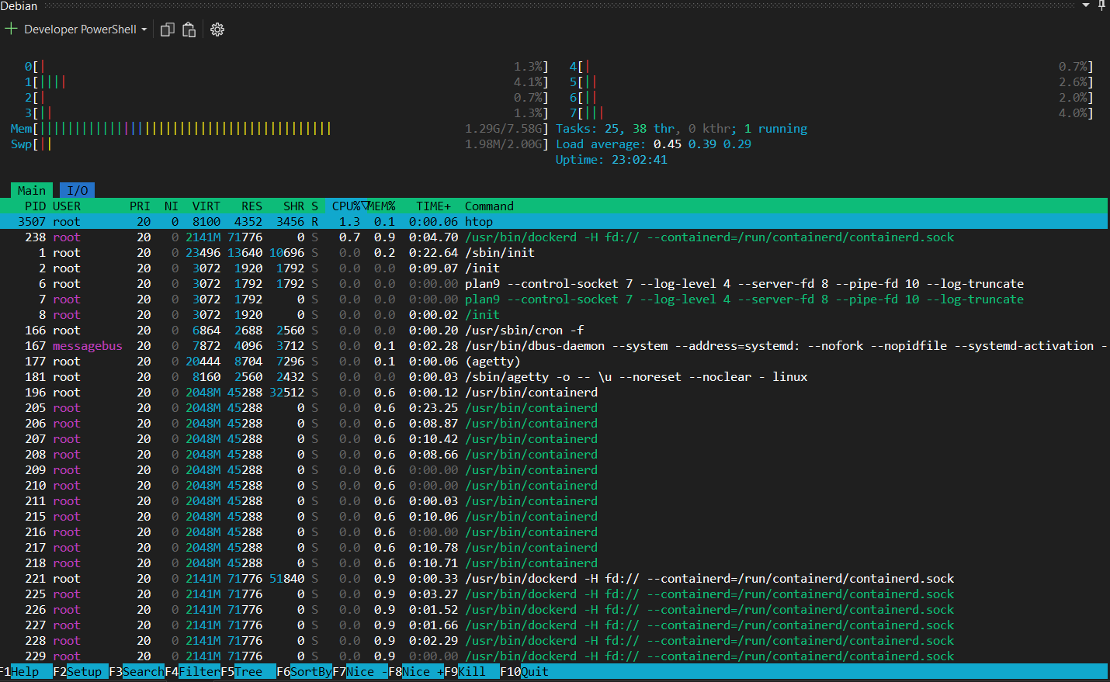
- Find all files > 100MB in /var/log.
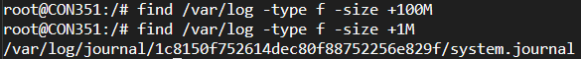
- Monitor CPU & memory usage in real time.

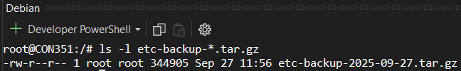
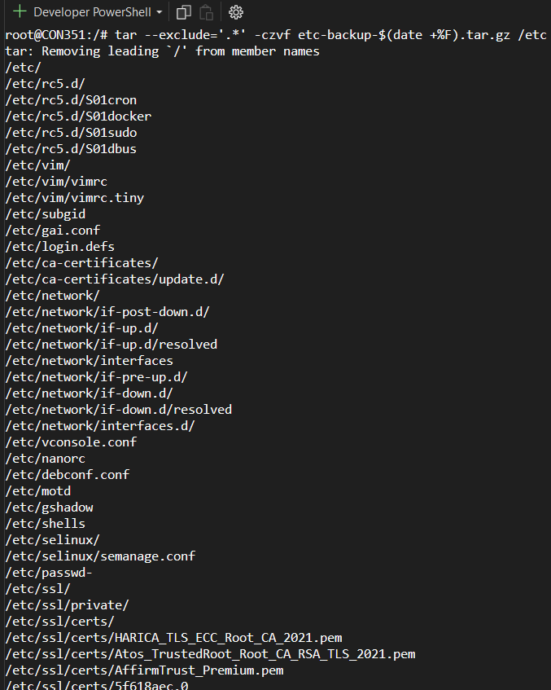
- Create a compressed backup of /etc and exclude hidden files.
- Kill a process running on port 8080.
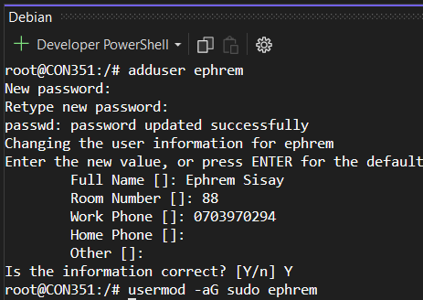
- Add a new user with sudo access

